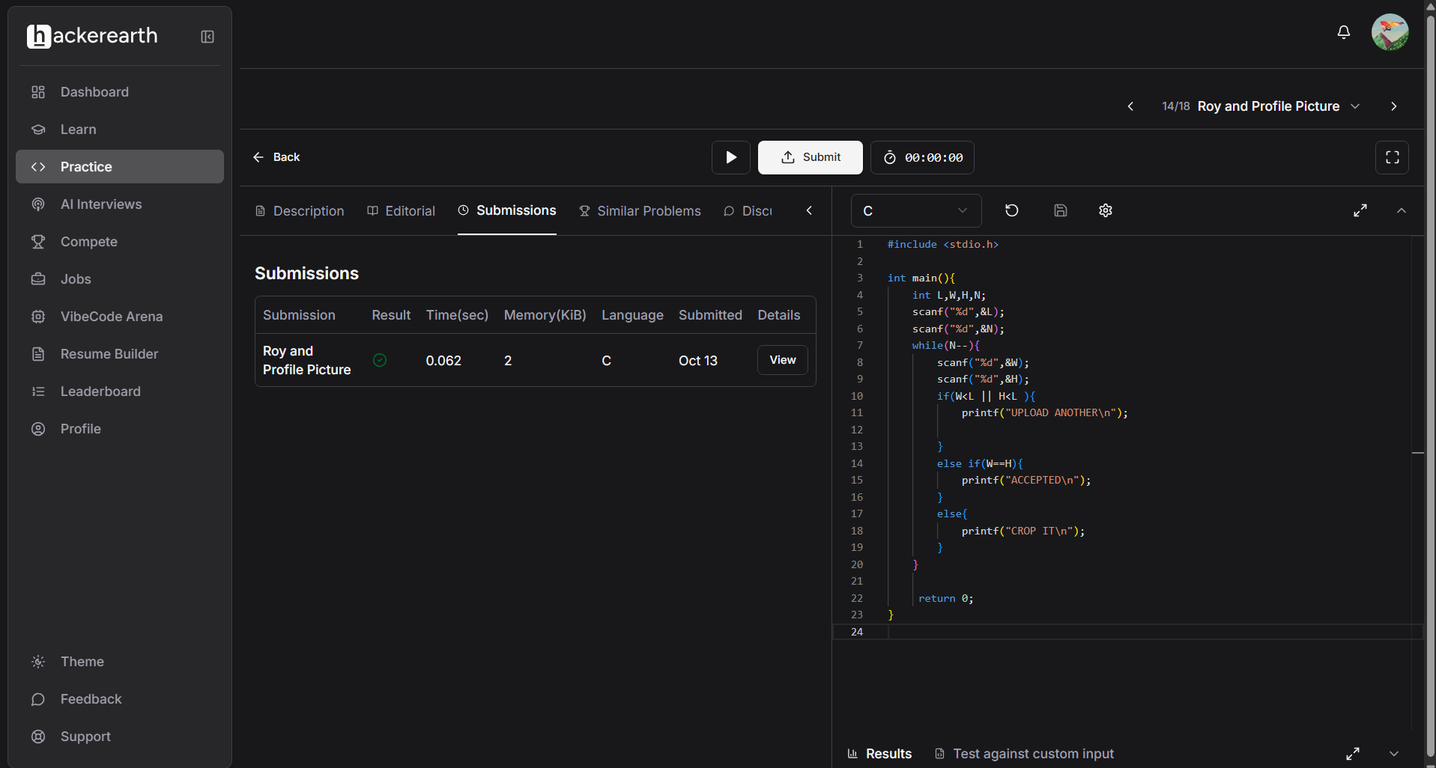
#include <stdio.h>
int main(){
int L,W,H,N;
scanf("%d",&L);
scanf("%d",&N);
while(N--){
scanf("%d",&W);
scanf("%d",&H);
if(W<L || H<L ){
printf("UPLOAD ANOTHER\n");}
else if(W==H){
printf("ACCEPTED\n");}
else{
printf("CROP IT\n");}
}
return 0; }

